WiFi Training Program
Module 5 – Assignment Questions
- What are the key features of Wi-Fi 6, 6E and 7 and how do they differ from previous standards like Wi-Fi 5 (802.11ac)?
Feature | Wi-Fi 5 (802.11ac) | Wi-Fi 6 (802.11ax) | Wi-Fi 6E | Wi-Fi 7 (802.11be)
Band | 5 GHz | 2.4 & 5 GHz | + 6 GHz | 2.4, 5, 6 GHz
Access | OFDM | OFDMA | OFDMA | OFDMA + MLO
Efficiency | Medium | High | Higher | Very High
Latency | Moderate | Low | Lower | Ultra Low
Features | MU-MIMO | TWT, BSS Coloring | Clean spectrum | MLO, 320 MHz

- Explain the role of OFDMA in Wi-Fi 6 and how it improves network efficiency.
OFDMA (Orthogonal Frequency Division Multiple Access) allows multiple users to share the same channel by dividing it into smaller subcarriers called Resource Units (RUs). Each user is assigned a portion of the channel, enabling simultaneous data transmission. This improves network efficiency, reduces latency, and is especially beneficial in high-density environments like campuses or offices.
- Discuss the benefits of Target Wake Time (TWT) in Wi-Fi 6 for IoT devices.
Target Wake Time (TWT) allows devices to schedule specific times to wake up and communicate with the access point. This reduces unnecessary power consumption and minimizes channel contention. It is particularly useful for IoT devices, as they can remain in sleep mode for longer durations, thereby extending battery life and improving overall network efficiency.
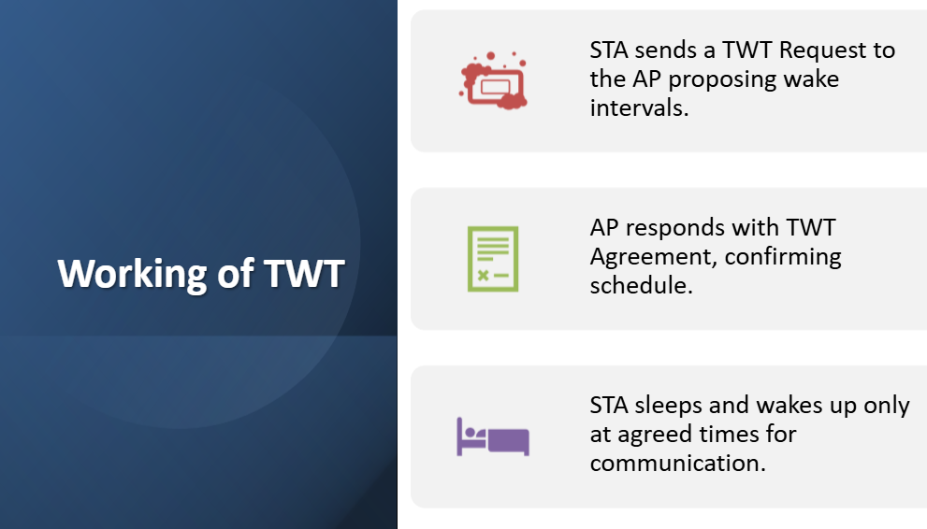
- Explain the significance of the 6 GHz frequency band in Wi-Fi 6E.
The 6 GHz band provides a large amount of new spectrum, enabling more non-overlapping channels and wider bandwidths. This reduces interference and congestion compared to the crowded 2.4 GHz and 5 GHz bands. It supports high-speed applications like AR/VR, gaming, and high-definition streaming, making Wi-Fi 6E more efficient and reliable.
- Compare and contrast Wi-Fi 6 and Wi-Fi 6E in terms of range, bandwidth, and interference.
Feature | Wi-Fi 6 | Wi-Fi 6E
Band | 2.4 & 5 GHz | + 6 GHz
Range | Better | Slightly lower (high freq)
Interference | More | Less
Bandwidth | High | Very high

- What are the major innovations introduced in Wi-Fi 7 (802.11be)?
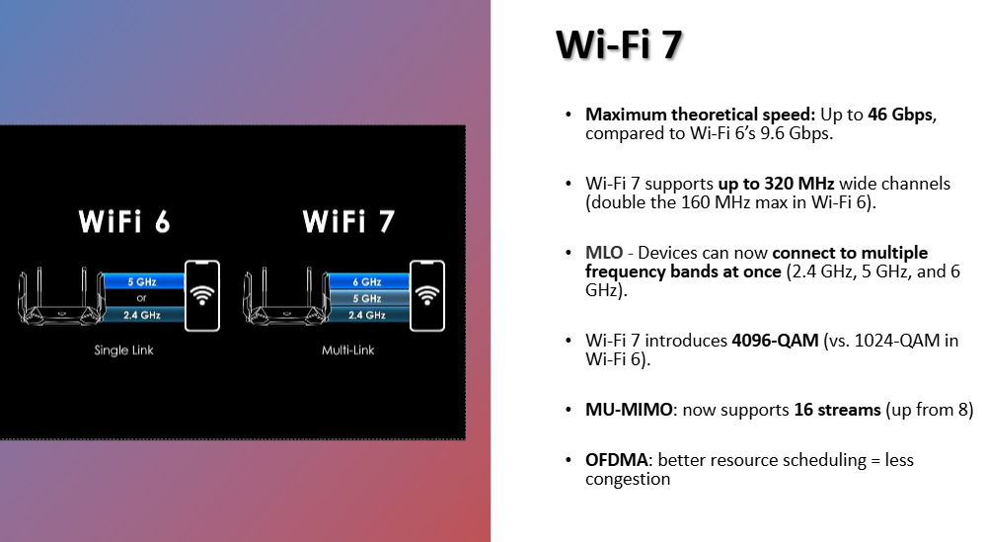
- Explain the concept of Multi-Link Operation (MLO) and its impact on throughput and latency.
MLO allows devices to use multiple frequency bands (2.4 GHz, 5 GHz, and 6 GHz) simultaneously for data transmission. This increases throughput, reduces latency, and improves reliability by dynamically switching or combining links based on network conditions. It ensures more stable and faster communication.
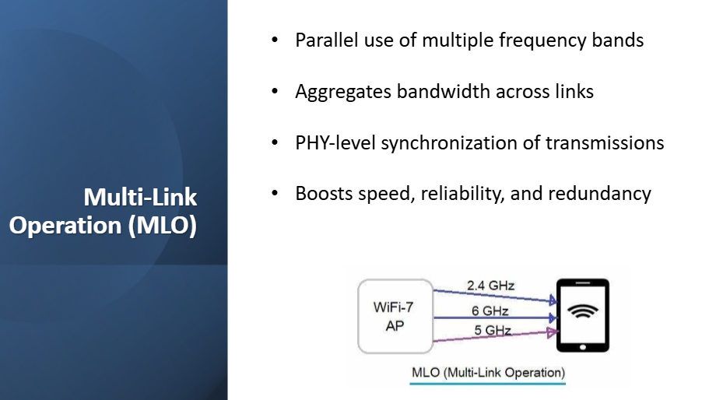

- What is the purpose of 802.11k and v, and how does it aid in roaming?
802.11k provides radio resource management by helping devices identify nearby access points and their signal strength. 802.11v enables network-assisted roaming by guiding devices to better access points. Together, they help devices make smarter roaming decisions, improving connectivity and performance.
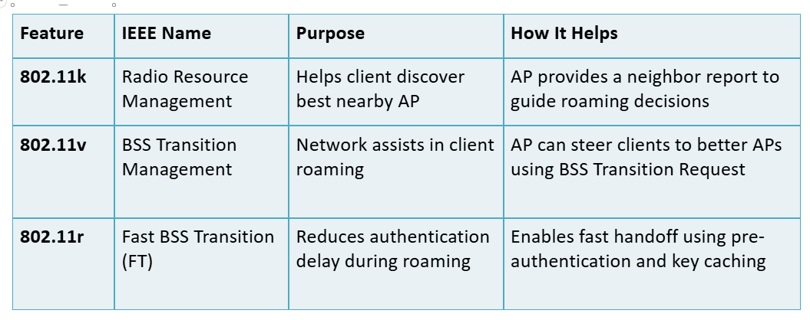
- Explain the concept of Fast BSS Transition (802.11r) and its benefit in mobile environments.
802.11r enables fast roaming by allowing devices to quickly switch between access points without performing full re-authentication. It reduces handoff delay by pre-sharing key information, making it ideal for real-time applications like voice and video calls in mobile environments.
- How do 802.11k/v/r work together to provide seamless roaming in enterprise networks?
802.11k helps devices discover nearby access points, 802.11v guides them to the best available option, and 802.11r ensures fast and secure transition between access points. Together, these protocols provide seamless roaming with minimal delay, improved user experience, and uninterrupted connectivity in enterprise networks.

